# Caremark.com – Savings Advisor/Drug Savings Opportunities

What It’s About

Drug Savings Alert – Email Example

Drug Savings Opportunity Page

Drug Savings Opportunities Detail

Drug Savings Alert - Email: Authentication Required (Not Registered Example)

Related Documents

**Description:** The Drug Savings Opportunities Tool is available via Caremark.com to help members identify lower cost options available to them on current maintenance meds (Desktop and Mobile Web). Feature may be client specific.

|  |
| --- |
| What It’s About |

* CVS Real Time Benefits (RTB) provides transparency and identifies options for lower cost alternatives based on member plan and deductible information.
* Full PBM visibility into costs, deductibles, and internal clinical expertise.
* Drug Savings Opportunities Email alert notifications to patients about these lower cost alternatives.
  + Includes the ability to direct members to clinically appropriate alternative drugs or fill options (**Example:** switch from 30 to 90-day fills) that are less costly for the member.
* The tool identifies “Best Savings Option” for each target drug based on member’s active refills/renewals.
* Members can compare their current prescription cost to multiple money-saving alternatives for mail and retail (**Example:** Generic equivalent, Therapeutic alternatives, 90-day Supply) and initiate a new prescription request for Mail alternative options digitally (Desktop and Mobile Web).
* Proactive targeting and outreach via Drugs Savings Alert to patients with saving opportunities.

Top of the Document

|  |
| --- |
| Drug Savings Alert – Email Example |

ECCM Drug Savings Alerts are triggered from HEE for total basket of drugs upon the member’s registration/program launch.

* Notify a member of potential savings via email based on member preferences when the member has a savings option.
  + Rx name limited to 3 letters in the email unless member changes preferences.
* Email alerts will list up to 3 target prescriptions with the top savings as well as what to change to.

**Note:**  Any additional items will be available on the Drug Savings Opportunities page.

* The member **must authenticate** on Caremark.com to view savings option details - they are deep linked to Drug Savings Opportunities post authentication.
* Email to NEW Drug Savings Opportunities page to view their savings options.

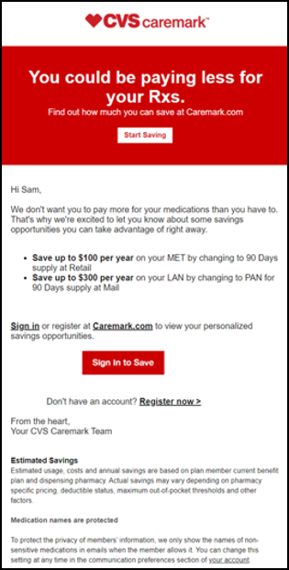

Top of the Document

|  |
| --- |
| Drug Savings Opportunity Page |

The page features display as follows:

* **Great News!** You can save money with these prescriptions.
  + Savings Opportunities listed here.
  + Displays up to 12 targeted prescriptions with savings per family member.
  + Opportunities are displayed in descending order by “Most Savings” for each family member (Cardholder, Spouse, Dependents oldest to youngest).
  + Sensitive medication and family access rules available on Caremark.com today are also applied for Drug Savings Opportunities.
* Need this information for your doctor? Print out a PDF of your savings options to share with your doctor.
* You're getting the best prices on these prescriptions we’ll let you know if new savings options become available.
* Need Help? List of 5 frequently asked questions/answers specific for Drug Savings Opportunities Tool.

Top of the Document

|  |
| --- |
| Drug Savings Opportunities Detail |

Perform the steps below:

|  |  |
| --- | --- |
| **Step** | **Action** |
| **1** | Log in or Register on Caremark.com.  The member will select Plans & Benefits then the Drug Savings Opportunities.   * Displays Current Prescription and Alternative Drug details for easy comparison. * Best Savings are shown by default and highlighted with the “**Best Savings**” indicator. * Savings options grouped by Generic Equivalent, Therapeutic Alternatives, and Days’ Supply. * Annual Savings for each Alternative Option are displayed. * The highest savings options display by default with additional alternatives available via the show more/show fewer features. * Mail alternative options are actionable to initiate a new prescription request digitally on Desktop and Mobile Web (New).   + **Note:**  Option to request a new prescription may be client specific. If a client does not offer their members the option to Request a New Prescription on Caremark.com, the member will not be able to initiate the request digitally.     If the member is already getting the best prices available, no Savings Opportunities will be presented. |
| **2** | **Add to Cart.**  **Go to Checkout.**  **Result:** This feature brings the member to the **Shopping Cart** or **Review Order screen** to initiate a new prescription request for home delivery alternative options digitally. |

Top of the Document

|  |
| --- |
| Drug Savings Alert - Email: Authentication Required (Not Registered Example) |

**Email Alert:**

5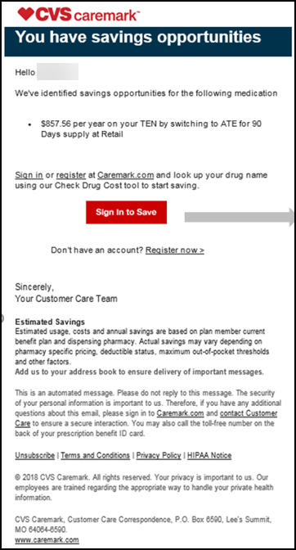

**Registration:** Refer to [Caremark.com – “New” Registration Flow.](https://thesource.cvshealth.com/nuxeo/thesource/#!/view?docid=2922d262-0374-4a26-820b-0a5ffe1085bd)

Top of the Document

|  |
| --- |
| Related Documents |

**Parent SOP:** [CALL 0045 Customer Care Web Support Email Response and Handling](https://policy.corp.cvscaremark.com/pnp/faces/DocRenderer?documentId=CALL-0045)

[CALL 0011 Authenticating Caller](https://policy.corp.cvscaremark.com/pnp/faces/DocRenderer?documentId=CALL-0011)

**Abbreviations/Definitions:** Customer Care Abbreviations, Definitions, and Terms

**Index:** Caremark.com - Work Instruction/Job Aid Index

Top of the Document

Not to Be Reproduced or Disclosed to Others without Prior Written Approval

**ELECTRONIC DATA = OFFICIAL VERSION / PAPER COPY = INFORMATIONAL ONLY**